
Low Level Warning Panel

RCALM2
RCALM2L
RCALM2Q
RCALM2B
RCALM2LQ
RCALM2LB
RCALM2QB
RCALM2LQB

Installation and Operation Manual

Table of Contents
Description Of Operation 2
Models 2
Installation 3
Safety Precautions 3
Included Components 3
Layout 3
Control Panel Mounting 3
Wiring 4
RCALM2/RCALM2Q 4
RCALM2B/RCALM2QB 7
RCALM2L/RCALM2LQ 9
RCALM2LB/RCALM2LQB 12
Operation 14
Safety Precautions 14
Usage 14
Specifications 14

Description Of Operation

The RCALM2 Display Panel provides a highly visible level warning display for water tanks.

The visual indication of power supply status (the green light) alerts the user in the event that power to the panel fails.

The amber low level light alerts the user to a low tank level and is accompanied by a repeating buzzer for audible alert.

Wiring to the amber light from a 2 way float switch can be reversed if desired to produce a high level warning function instead of low level.

Models

RCALM2 | Light, Buzzer, BMS, 230vac Float Switch
RCALM2L | Light, Buzzer, BMS, 24vdc Float Switch
RCALM2Q | Light, BMS, 230vac Float Switch
RCALM2B | Light, Buzzer, 230vac Float Switch
RCALM2LQ | Light, BMS, 24vdc Float Switch
RCALM2LB | Light, Buzzer, 24vdc Float Switch
RCALM2QB | Light, 230vac Float Switch
RCALM2LQB | Light, 24vdc Float Switch

Installation

Safety Precautions
Mains Voltage – There are exposed electrical conductors inside this appliance. This appliance must be installed and serviced by a competent electrical technician to the current requirements of BS7671 and IEEE recommendations. Before servicing this appliance, normal safe isolation procedures should be implemented.

Do not touch any connection terminals while energised.

Do not attempt to service this item when wet, or in a wet or high humidity environment.

If the housing of the control panel becomes damaged, you must shut down and securely isolate this appliance immediately.

Included Components
RCALM2 Control Panel
Attached mains cable
Installation & Operation Manual

Float switch or level switch.

Layout
The control panel cannot be mounted outside, it is not fully weather resistant, but can be installed in sheltered outdoor locations (barns, covered areas, etc).

Suitable circuit protection must be installed and should include as a minimum a suitable earth, overcurrent protection, and residual current protection at 30mA, ideally on it's own circuit, but always in accordance with BS7671 and applicable regulations.

Control Panel Mounting
Open the cover of the control panel. There are 4 recesses, one on each corner of the panel. Drill through at these locations and attach to the wall or a suitable support, taking care not to damage cabling inside the panel. Fixings are not included and should be selected to suit the material to which the panel will be mounted.

Wiring

RCALM2/RCALM2Q

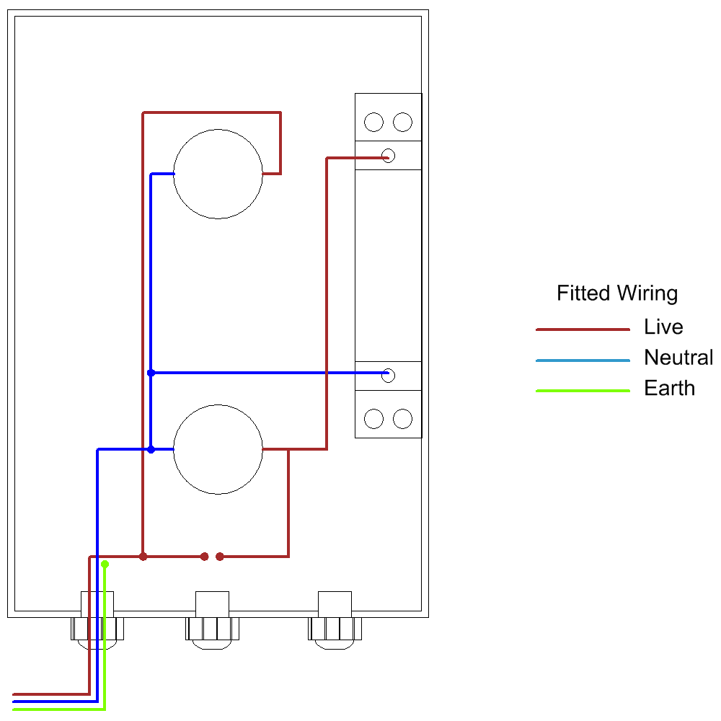
The control panel is supplied with wiring installed in the drawing shown above. The float or level switch needs to be fitted as shown in the next diagram.
Connections

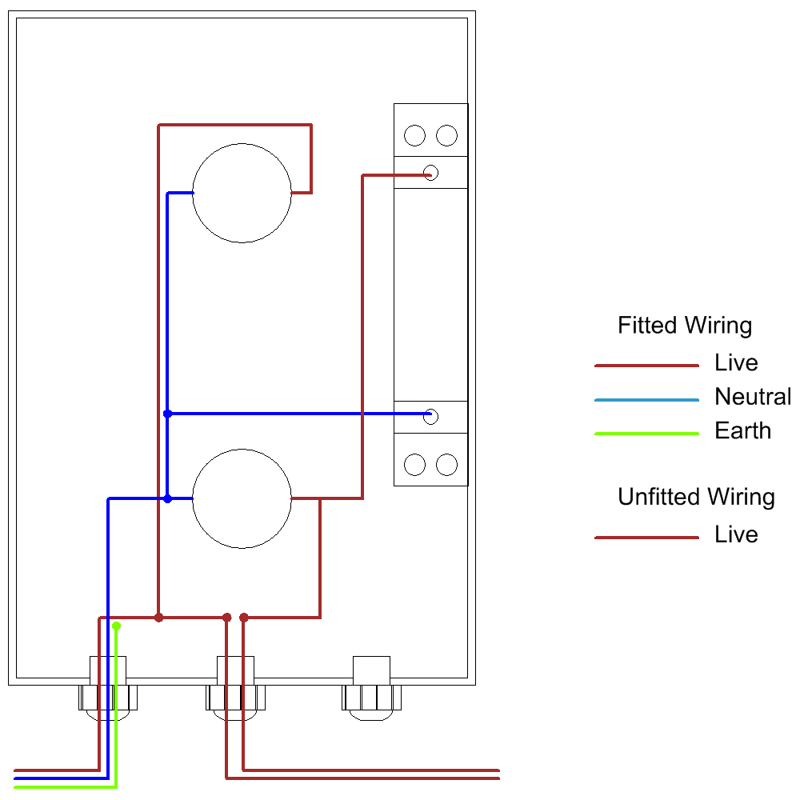

Note that both wires to the float switch or level switch are live.

Note the green/yellow earth connection is provided for circuit protection to the appliance and has no function within the display panel which is Class 2 rated.

BMS Connection

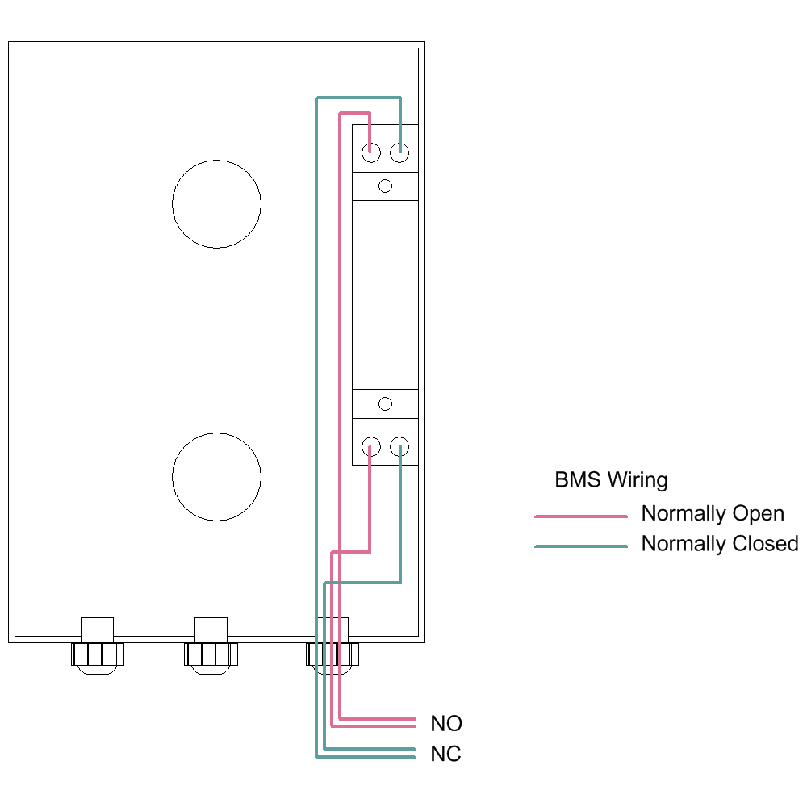

RCALM2B/RCALM2QB

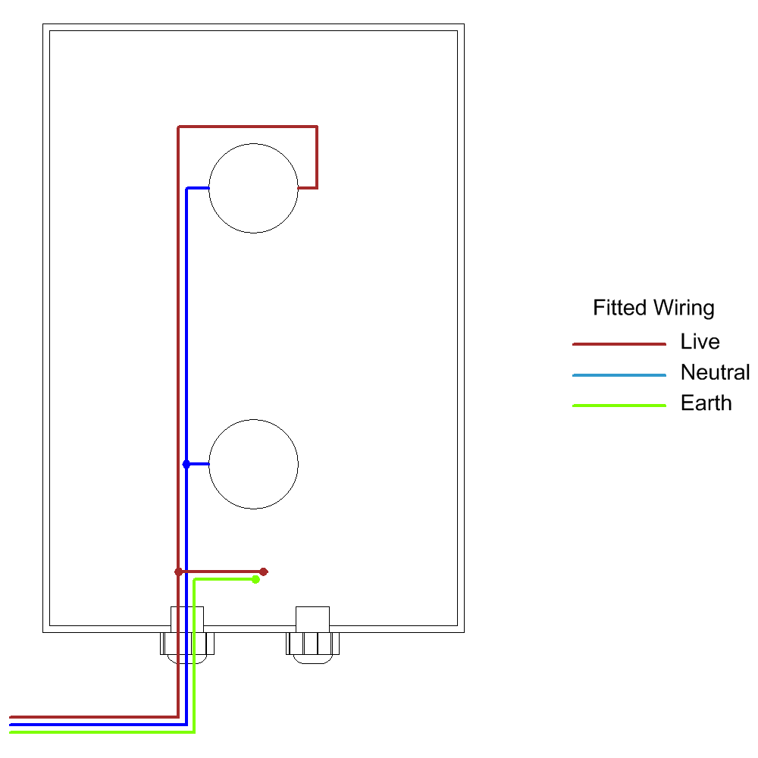
The control panel is supplied with wiring installed in the drawing shown above. The float or level switch needs to be fitted as shown in the next diagram.
Connections

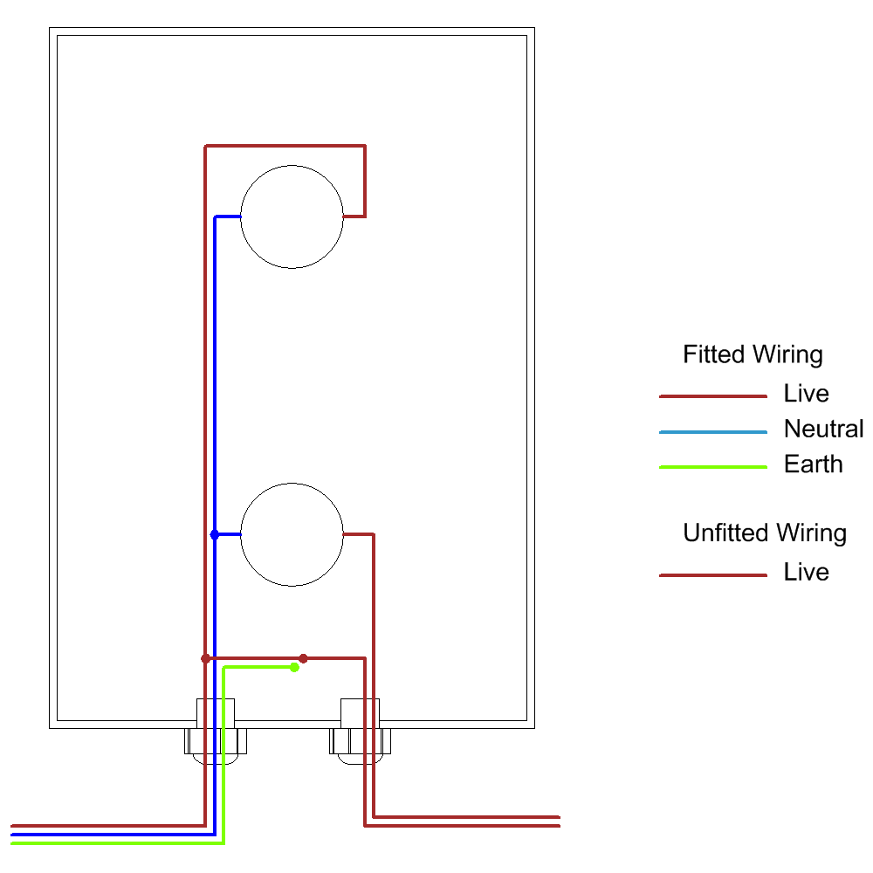

Note that both wires to the float switch or level switch are live.

Note the green/yellow earth connection is provided for circuit protection to the appliance and has no function within the display panel which is Class 2 rated.

RCALM2L/RCALM2LQ
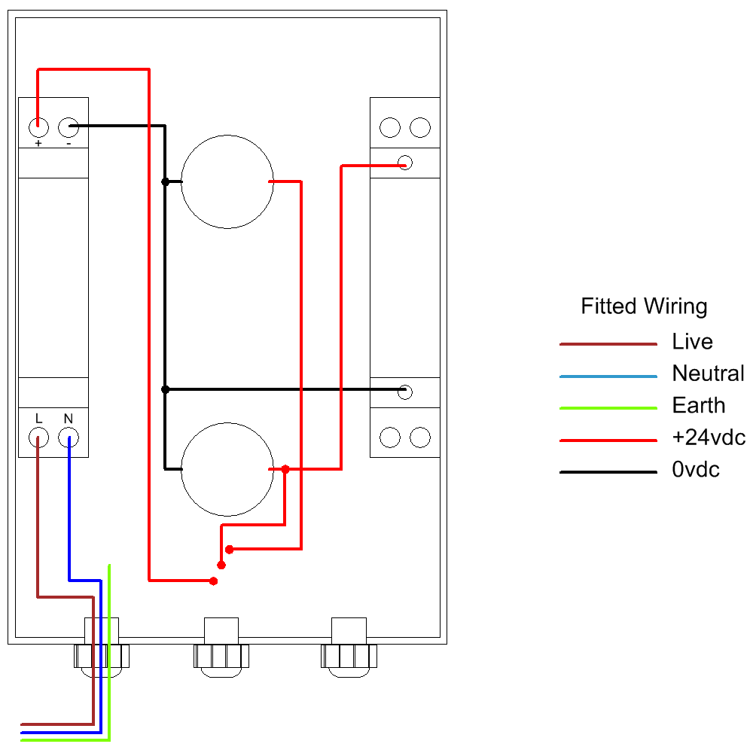

The control panel is supplied with wiring installed in the drawing shown above. The float or level switch needs to be fitted as shown in the next diagram.
Connections

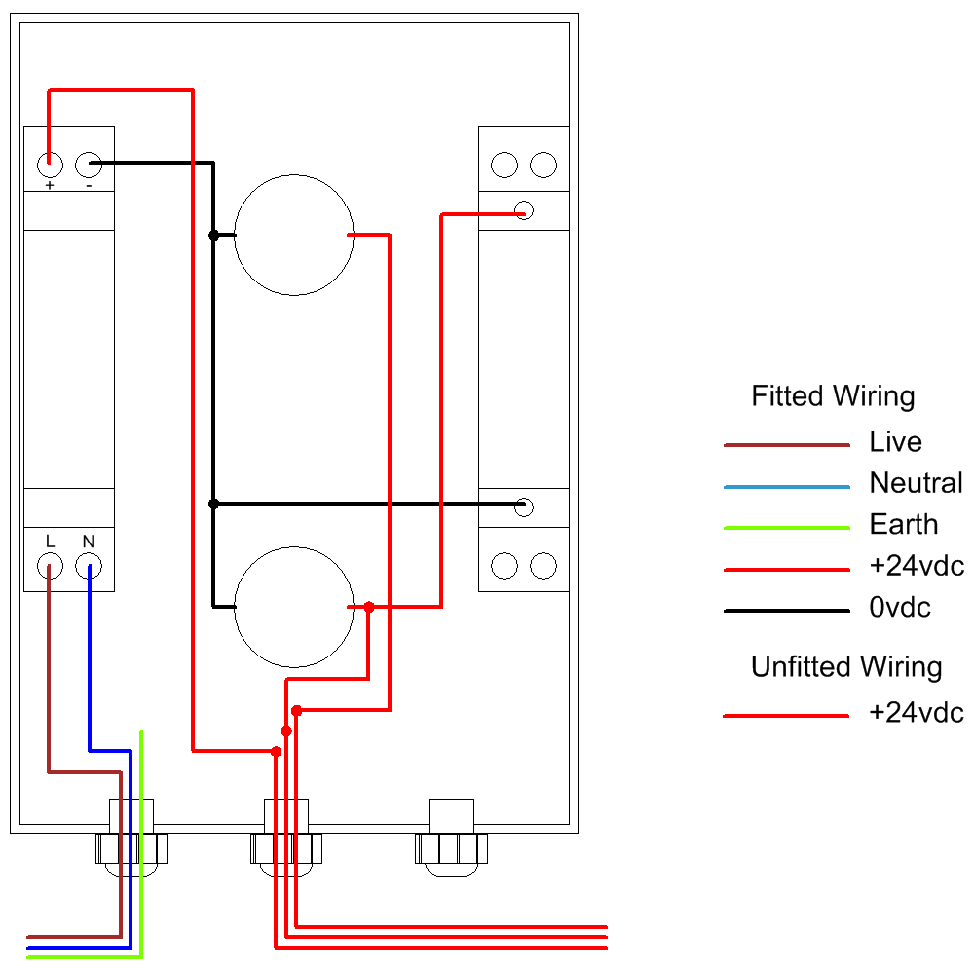

Note that both wires to the float switch or level switch are live.

Note the green/yellow earth connection is provided for circuit protection to the appliance and has no function within the display panel which is Class 2 rated.

BMS WIRING

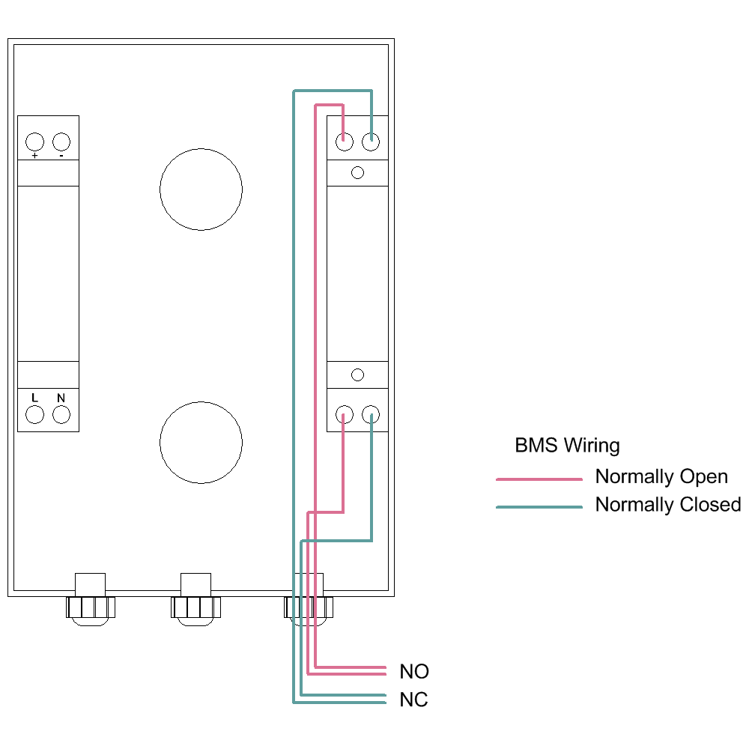

RCALM2LB/RCALM2LQB
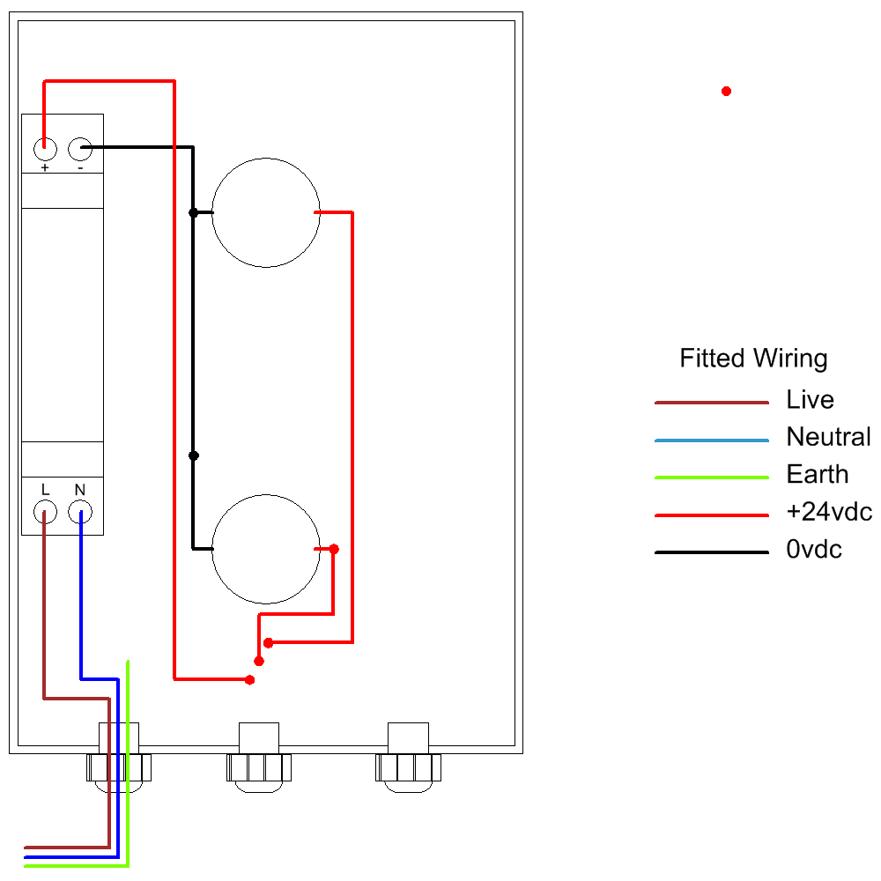

The control panel is supplied with wiring installed in the drawing shown above. The float or level switch needs to be fitted as shown in the next diagram.
Connections

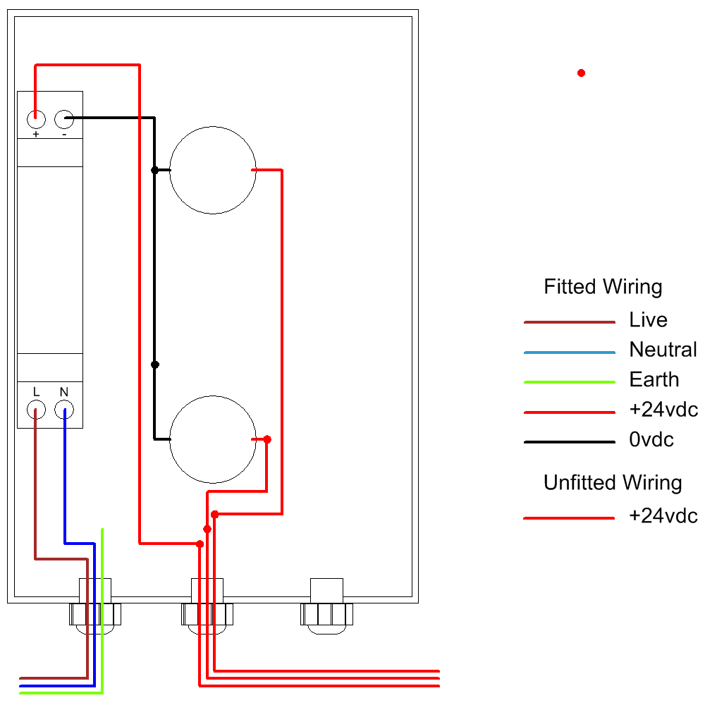

Note that both wires to the float switch or level switch are live.

Note the green/yellow earth connection is provided for circuit protection to the appliance and has no function within the display panel which is Class 2 rated.

Operation

Safety Precautions
Mains Voltage – There are exposed electrical conductors inside this appliance. Before servicing this appliance, normal safe isolation procedures should be implemented.

Do not attempt to operate this item when wet, or in a wet or high humidity environment.

If the housing of the control panel or attached wiring becomes damaged, you must shut down and securely isolate this appliance immediately.

Usage

Once energised the display panel will show a green light. This light is constantly energised as long as there is power to the panel. It indicates that the tank level is being monitored, and that there has been no disconnection or trip of any circuit breaker.
If the green light goes out, check the circuit breaker at the consumer unit supplying this circuit. Reset if necessary. If the circuit trips again do not reset but instead have the system checked by an electrically qualified service agent or a qualified electrician.
The amber light shows that the tank is at a low level, as indicated by the installed position of the float switch or level switch.

Specifications
Dimensions 180mm x 110mm x 90mm
Enclosure Material Polystyrene
Ingress Protection IP66
Electrical Protection Class 2
Voltage 230VAC 1~

